Research Review Presentation on

**Building a Better Battery with Data-Driven Techniques**

*Submitted By*

Prateek Gandhi

20SD06011

*Under the Supervision of*

Dr. Pattabhi Ramaiah



School of Mechanical Sciences

Indian Institute of Technology, Bhubaneswar

September 2021

**Building a Better Battery with Data-Driven Techniques**

Prateek Gandhi

20SD06011

**Abstract:**

Organic solvents are used as electrolytes in lithium-ion batteries currently. They work well by most accounts, lithium flows through them pretty quickly, they're manufactured at scale but organic solvents are a problem because they're very flammable. Hence there is a need for entering the unknown part of material science where we are combining what we know from the conventional approaches with these new ideas from big data and machine learning to accelerate the current work of search for materials for solid electrolytes in the lithium-ion batteries. The development of new solid electrolytes could ease a lot of concerns over the safety, stability, energy density, and cycle life of commercial batteries. Furthermore, the development of new solid electrolytes could facilitate the development of structural batteries for the weight and volume delicate applications of electric spacecraft and aircraft.

**Keywords:** Solid Electrolyte, Machine Learning, Lithium-ion batteries, Superionic Conductors.

**CONTENTS**

| **Contents** | **Page No.** |
| --- | --- |
| INTRODUCTION  1.1 Theoretical background  1.2 Working of a battery  1.3 Scope of improvements  1.4 Electrolytes | 1  1  1  2  3 |
| REVIEW OF THE TOPIC  2.1 Literature review  2.2 Major focus areas  2.3 Experimentation / Model Formulation  2.4 Important Findings | 3  3  5  6  8 |
| CONCLUSION/ SUMMARY | 10 |
| REFERENCES | 12 |

**1. INTRODUCTION**

**1.1 Theoretical Background**

Environmental and energy-based issues have become the major areas of concern in today's day and age. The search for alternative sources of energy is ongoing. The energy economy, at present, which is mainly based on fossil fuels, is at risk due to the decrease in non-renewable resources and the continuously increasing demand for energy. To add to it, CO2 emissions associated with the use of fossil fuels are one of the main genesis of global warming, which is becoming an important issue at the global level.[1]

Investments for the utilization of renewable energy resources are growing worldwide, with particular attention to solar, wind and battery power systems. Batteries have many advantages as a substitute source of energy storage mechanisms. At present, the conventional battery technologies, such as lead-acid and nickel-cadmium, are steadily being replaced by lithium-ion batteries, fuel-cell technologies and nickel-metal hydride batteries. Li-ion battery stands as a precursor and market leader when compared to the other energy systems.

Lithium-ion batteries, in particular, have enabled major innovations across the spectrum of energy technologies. In the automotive sector with Tesla. Other companies are thinking about heavy equipment being powered by batteries like aeroplanes and of course, mobile electronics. So it is safe to say that Lithium-ion batteries are run the gamut of powering all kinds of technologies.[1]

**1.2 Working of a battery**

The cross-section of a cylindrical battery, which can be visualized as having a structure similar to a roll of paper that is connected to the positive and negative terminals. The cell is made up of several different layers. First, we have a copper foil which acts as the current collector for the anode then we have a porous anode which is normally made up of graphite, on top of that we have a microporous separator which prevents the anode and cathode from touching each other. Then we have a porous cathode which is made up of a transition metal oxide and an aluminium foil which acts as the cathode current collector in each of the porous phases. We also have a liquid electrolyte that allows for the movement of lithium ions. When the battery is fully charged, lithium exists in between the carbon layers of the graphite. When the battery is discharged the lithium becomes a lithium ion and an electron. The lithium ions can travel through the electrolyte towards the cathode however the electrons have to go around an external circuit where useful electrical work can be extracted. At the cathode, the lithium ions and electrons recombine and go into the layers of the transition metal oxide in a process called intercalation. When charging the battery the opposite reaction occurs moving the lithium back into the anode. This back and forth motion coins the term “rocking chair mechanism” which represents how a lithium-ion battery works.[17]

**1.3 Scope of improvement**

These batteries aren't perfect. There are four main areas where battery technology can get a lot better. Safety, of course, should be the top priority. The safety of batteries needs to be unquestioned and it's very questioned presently. Other factors like energy density always need to come up, cost always needs to come down and cycle life needs to improve. For electric vehicles where the user would want to be able to drive for 10 or 20 years without replacing the battery, it should have a really excellent cycle life. The ways that these metrics can be improved are being explored currently. Whilst there's been year-on-year improvements to batteries, there still is a need for significant improvements to achieve mainstream adoption. One of the key metrics is cost, where the frequently cited number to be cost comparable with the internal combustion engine is 100$/kW-h at the pack level which means we need a cell cost to be about 50$/kW-h. Currently, this is just over 200$/kW-h at the pack level and just over 100$/kW-h at the cell level.[17] Though this varies depending on the volume and application. Next, we need to improve the energy density, which represents the range of an electric vehicle, from approximately 250 W-h/kg to about 500 W-h/kg. Also, there is a need to increase the power density which represents the acceleration of the electric vehicle from current levels of about 3 kW/kg to 12 kW/kg.[17] However, as we do this we shouldn't forget about safety as we add more and more energy, it becomes more dangerous and thus there's a need to eliminate the threat of thermal runaway. Lifetime is also critical especially as we aim to apply these batteries in the large-scale grid, energy storage applications and the aim is to hopefully increase the lifetime from about 8 years to 15 years. If we want to electrify more applications, the temperature range over which cells operate must also be improved and as we manufacture more and more of these cells we should also aim to improve their predictability and consistency. Finally, as we start to produce many millions of these cells the sustainability of the system also needs to be considered with the recyclability generally quite low at the moment but with a need to move to near 100% recyclability of the materials in the near future.

**1.4 Electrolytes**

One of the aspects of battery technology that is at the heart of a lot of these problems are the electrolytes used. The battery has an anode and a cathode, they are the two terminals and then there is an electrolyte in the middle that separates the two terminals and it mediates the transport of lithium back and forth when the battery is charged and discharged. In the cells of the smartphone, of the laptop, the electrolyte used is an organic solvent, which is liquid. Aqueous or water-based solvents can’t be used because lithium reacts with water. So organic solvents are used. They work well by most accounts, lithium flows through them pretty quickly, they're manufactured at scale but organic solvents are a problem because they're very flammable. Example: nail polish remover. So if the battery is overheated or punctured, it could catch fire and that is going to be a huge issue. But aside from that, they're also not great because they are very reactive so a large voltage across a liquid electrolyte can’t be put because it'll start to vaporize and break down. They are also low density and they don't suppress dendrites and dendrite growth is one of the main causes of early battery death.[5]

**2. REVIEW OF THE TOPIC**

**2.1 Literature Review**

The research is headed towards replacing the liquid electrolyte with the solid material that can do the same job and that hopefully has all the benefits of the liquids without these major drawbacks. Solids are inherently more stable and less reactive. They have higher density so smaller devices could be made potentially and they're very rigid so they can suppress this growth of dendrites and potentially lead to increased cycle life. So solids can help on all the metrics that were originally discussed. Therefore, solid electrolytes are fascinating and a very promising way to go to improve battery technology.[5]

It's been over 40 years and research is still going on on this problem because solid electrolyte materials that work in batteries have to satisfy a bunch of criteria at the same time as shown in Figure 1.

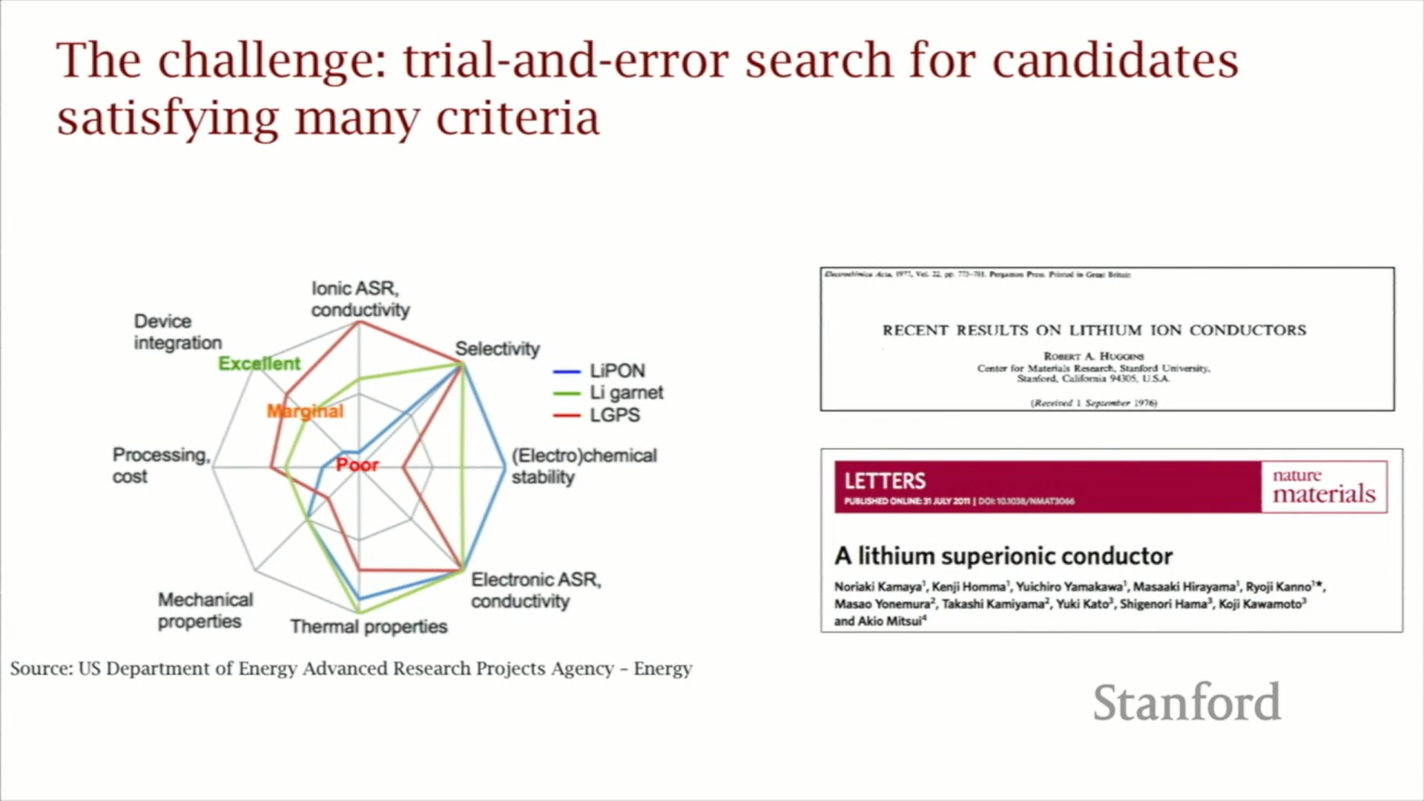

Fig. 1: Conditions on which potential candidate materials are being searched. [3]

There is conductivity and stability as well as processing ease from the manufacturing scale point of view. So there are a lot of requirements that should be met at once and if searching for promising materials is done based on trial and error, then the odds of finding a material that is going to satisfy ten criteria at once is going to be extremely low since predicting ionic conductivity of any material is very hard.[5]

From the 70s to the present we have generated a lot of data of XY pairs where X is a material that was picked by a random guess and Y is the property which was being measured, ionic conductivity for example. So now the idea is to reformulate this as let's not just keep trying things but let's take this data that's already out there and let's reformulate this as a problem of supervised learning where we are taking the X and the Y's we know and look for the function f which can map between the two of them and in the material science world this is a structure-property relationship.[5]

The question which is driving the research is can we learn effectively from the data that we have already generated without having to generate a whole bunch more. And machine learning is the way to do that to hopefully go beyond trial and error.

There are all kinds of different combinations of elements, which are close to infinite and hence this becomes just totally intractable. That is where the power of machine learning comes in so in the landscape of the accuracy of a scientific approach versus the size of the searchable space, machine learning is going to be less accurate than DFT (density functional theory simulations) but orders of magnitude faster as shown in figure 2.

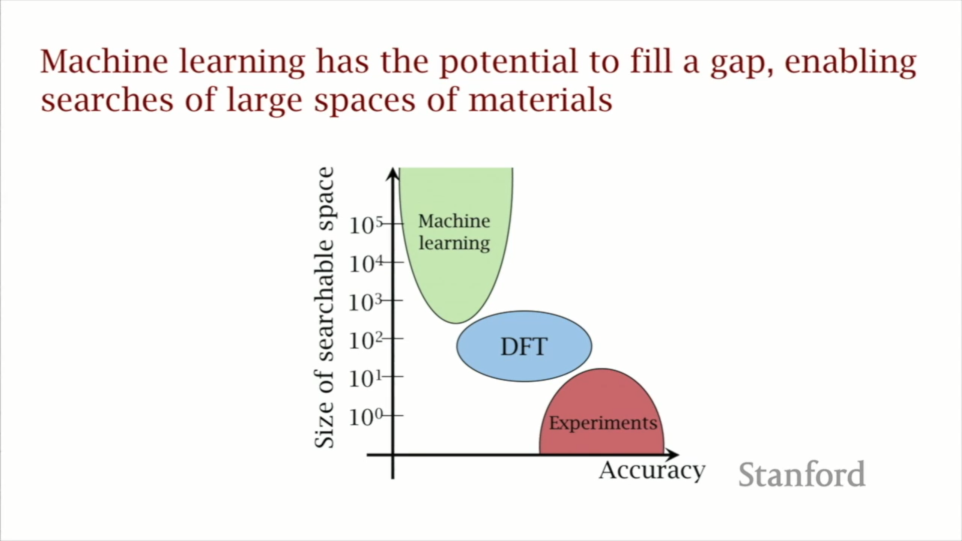

Fig 2: Comparison of ML, DFT and Experiments on size of searchable space and accuracy. [4]

So it is easy to get through billions of candidate materials. This will accelerate the development of solid-state batteries as it beats trial and error.

**2.2 Major Focus Areas**

With the model and results presented herein, a new approach for the discovery of solid electrolytes with the potential to identify the next generation of high-performance Lithium-ion battery solid electrolytes from thousands of candidates is presented. The development of new solid electrolytes could ease a lot of concerns over the safety, stability, energy density, and cycle life of commercial batteries. Furthermore, the development of new solid electrolytes could facilitate the development of structural batteries for the weight and volume delicate applications of electric aircraft and spacecraft. Additionally, this screening approach allows for the inclusion of additional requirements, including environmental concerns like earth abundance.[5] The impact of a highly stable new solid material with liquid-like lithium conduction cannot be overemphasized: solid-state Lithium-ion batteries stand to improve on the safety, performance, and lifetime of the energy storage technology, and in doing so help to realize an electrified future with less dependence on fossil fuels.

**2.3 Experimentation / Model Formulation**

**Experimentation:**

Experimental measurements of ionic conductivity at room temperature for 40 different materials are gathered and these are all crystalline materials and they have well-defined structures that have been characterized and so for all 40 of them, the researchers came up with 20 features which are essentially pieces of information that they think might have some bearing on predicting ionic conductivity. Some of them came from the literature, from things that people have proposed, some of them came from intuition.[5]

The first thing that they did was that they just computed all twenty of these for the forty materials and they looked at them one by one just to see which one predicts conductivity and the correlation coefficients are shown in figure 3 and we can see that they are all small. They are all less than plus or minus 0.3.

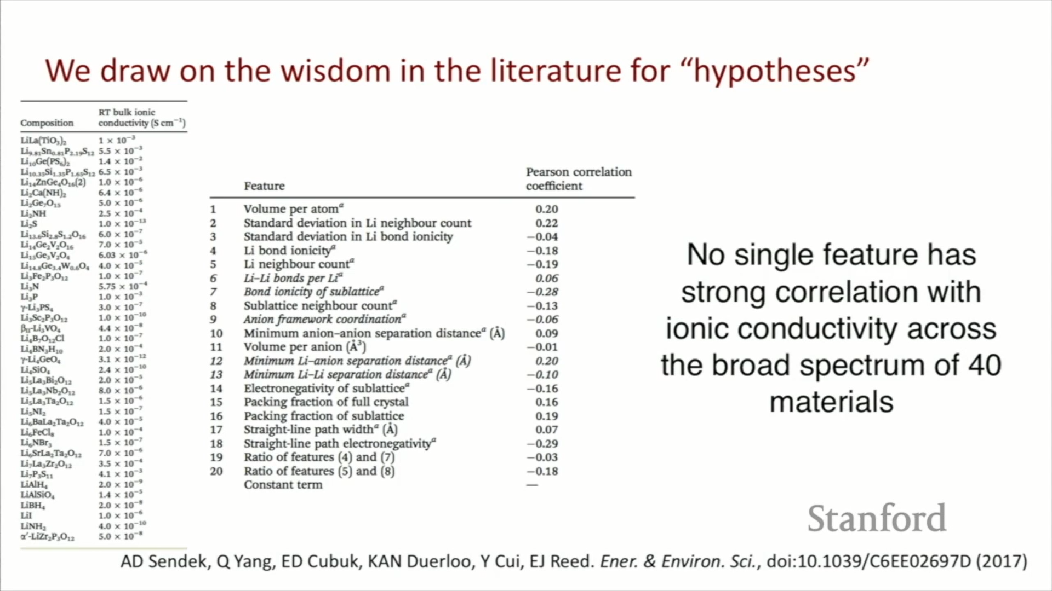

Fig 3: 40 experimental measurements of conductivity and 20 features for predicting ionic conductivity. [5]

So out of their initial twenty guesses, none of them really were good predictors. So they have used an axiom in machine learning which is that if we have a bunch of weak learners or weak descriptors, we can put them together in a creative way that we can create a strong learner or a better predictor.[5] So even though there's no single feature with a strong correlation across this diverse set, we hope that we can creatively put these together in a way that gives us that predictive power.

**Model Formulation:**

To move forward we have to choose a model that we want to use. A binary classifier model was chosen which just predicts essentially a yes or a no. So the training set was broken down into good conductors and bad conductors with a cut-off of 10-4. So that is the lowest we can have and still have it be considered a good electrolyte material. This splits this up into about 1/4 good conductors about 3/4 bad conductors. There are no conventions in this sort of space especially in machine learning with this small of a data set but after testing other models, this was the one that the researchers found worked the best as shown in Eqn. 1.[5]

$Psuperionic(x) = \frac{1}{1 + exp(-θ^{T}x) }$ (1)

In the logistic regression, it has *θ* transpose *x* in the denominator. *x's* are the combination of features and the *θs* are the regression coefficients. So the question is now which of those 20 features would give us the best predictive model for that data that we're training it on. We take the 20 candidate hypotheses and the 40 data points and then we want to find the best feature set we want to fit the data to. Having a small data set usually is bad because we can have problems with overfitting and it is harder to deal with. But one of the benefits is that with a small data set we can search the entire model space in a reasonable amount of time. We then measured the cross-validation error of the model which tells about how the model is going to predict on unseen data and that's what the solid red line represents in figure 4. This is plotted against the number of features. From the figure, there is a minimum in the cross-validation error at five features.[5]

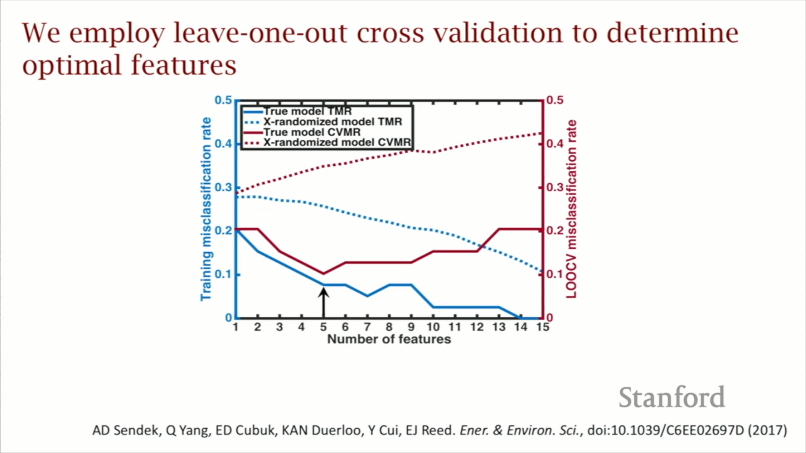

Fig 4: Cross-validation to determine optimal features. [5]

That means that there is one model out of this one and a half million which gives us the least error and it's the best model that we could find with this data set. The dotted red line is where we replaced all that feature data with 20 columns of random noise that was just generated by a random number generator and the fitting process was redone. The error is about three times lower when we're using the real features than when we're using noise and hence it serves as a confidence builder that we are building this model on real information and we're capturing the result which is statistically significant here. The hope is that this optimal model would give an accurate guess about 90% of the time. The model developed is shown in Eqn. 2.

$θ^{T}x = 0.817LLB - 1.323SBI - 1.028AFC + 2.509LASD - 1.619LLSD - 1.944$

(2)

Where *LLB* is Lithium-lithium bond number, *SBI* is Sublattice bond ionicity, *AFC* is Anion framework coordination, *LASD* is Li-anion separation distance and *LLSD* is Li-Li separation distance. These five features are easily interpreted in a material science context. This equation is based on five pieces of information and this takes, if we set it up an automated script, less than a second like a microsecond to compute, whereas it would have taken one week to get an estimate of conductivity with density functional theory simulations which use physics and have to solve the Schrodinger equation and simulate atoms. Hence, this is a huge speed improvement.[5]

**2.4 Important Findings**

Over 12,000 candidate materials were found in the online database of the materials project which is curated at Lawrence Livermore National Laboratory. They also included six extra screening metrics which weren't built from machine learning. These were built on simple heuristics. So when we take these twelve thousand candidate materials we first apply these six screening metrics, and this gets the number of candidate materials to reduce down to around 300 materials. 300 materials are still too many for researchers to do 300 experiments or 300 simulations so this is where we apply the conductivity predictor. After applying it to those 300 materials, we're able to get it down to 21 and hence we're able to do the first multi-property screening of all known lithium-containing compounds for solid electrolyte materials because we have this conductivity model which is so much faster than what we had before.[5]

Out of those 21, we found about half of them showed really exciting levels of lithium-ion conduction at room temperature and we found this through doing these physics-based simulations.[5]Figure 6 is a mean squared displacement plot for how far lithium migrates in time in these different materials.

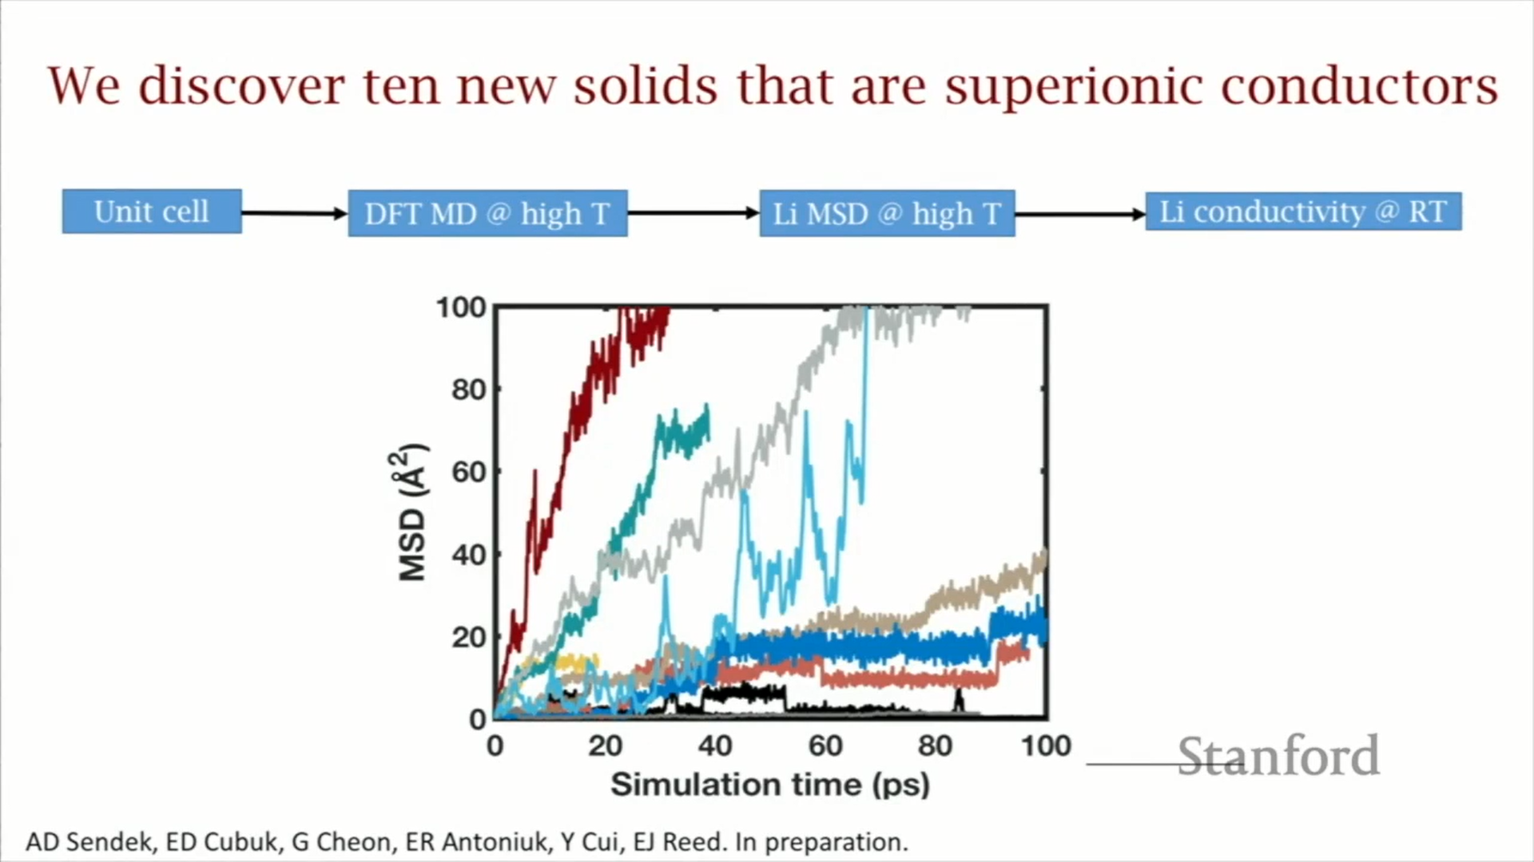

Fig 6: Mean squared displacement plot of Lithium migration for 10 materials. [5]

This is a common way of showing and tracking how far lithium migrates in time in these different materials. Since these physics-based codes are really slow we have to operate on a picosecond time scale. The slopes of these curves are what tell us about conductivity which is our original metric. We can break these materials down into three categories so we have four materials here that are on par with the best-known materials with a conductivity of about 10-2 Siemens per centimetre which is exciting. We then have materials with a conductivity of 10-4, which is near the cutoff of good materials. Then we get several materials that don't show any motion at all and so this gives a 50% hit rate for the model success rate.

If we compare it to the incumbent methods, this model’s success rate is between 35 to 50 per cent.[5] The same procedure was repeated but this time the simulating materials were chosen at random and what we found, in that case, was that the success rate was about 10%. So we can see that we have about a three to five times improvement in the rate of success. The histogram in figure 7 shows that we have three categories - bad conductors, medium conductors and good conductors.

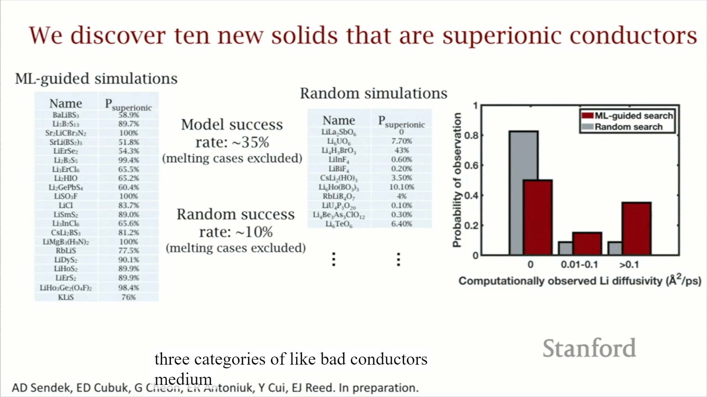

Fig 7: Comparison of ML guided search and Random search. [6]

The grey bars are what we find with random searches and then the red bars are what we find with machine learning guided searches. We can see that we get about four times more good conductors with ML guided searches. Therefore there is a tangible improvement that's offered here by machine learning. This 3x improvement came from a model that was trained on just 40 data points.[6] Therefore, it's worth pointing out that even small amounts of data can give real tangible improvements in the way that we discover materials.

**3. CONCLUSION/ SUMMARY**

It is a difficult challenge of getting good iron conductors that are electrochemically stable as well. For an electrolyte, in a conventional battery, we put three demands on it if we move beyond conductivity. We also need it to be stable against oxidation at the cathode because at the interface it tends to be oxidized. Also, we need it to be stable against reduction as well as it is touching anode and hence it will tend to be reduced. So we are looking for a material that can satisfy all of these demands at once. It's a very tough optimization to do.[6]

One method that has been proposed to make this optimization a little bit easier is to split the electrolyte up into two electrolytes as shown in figure 8.

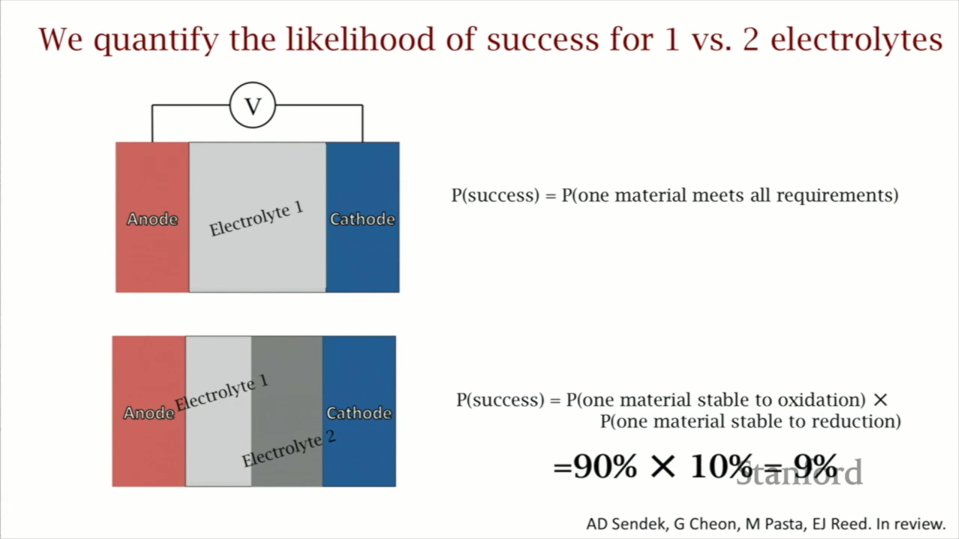

Fig 8: Splitting up the electrolytes to ease the optimization [6]

Now both of them need to have good ionic conductivity but electrolyte one is touching the anode and not the cathode so it only needs to be stable against reduction. Electrolyte two is only touching the cathode and not the anode so it only needs to be stable against oxidation. Therefore by using this method the demands can be reduced on these materials but then this method introduces additional difficulties. Manufacturing this configuration is hard. Getting the materials to stack right on top of each other with minimal defects and less interfacial resistance is tough. It is not clear which strategy is better since this has been something that's more recently thought about.[6]

**4. REFERENCES**

1. Manthiram, Arumugam. "An outlook on lithium ion battery technology." ACS central science 3, no. 10 (2017): 1063-1069.
2. Liu, Kai, Yayuan Liu, Dingchang Lin, Allen Pei, and Yi Cui. "Materials for lithium-ion battery safety." Science advances 4, no. 6 (2018): eaas9820.
3. Wurzelmann, Sam. "Advanced Research Projects Agency-Energy (ARPA-E): Innovation through the US Department of Energy." Center for Climate and Energy Solutions (2012).
4. Cubuk, Ekin D., Austin D. Sendek, and Evan J. Reed. "Screening billions of candidates for solid lithium-ion conductors: A transfer learning approach for small data." The Journal of chemical physics 150, no. 21 (2019): 214701.
5. Sendek, Austin D., Qian Yang, Ekin D. Cubuk, Karel-Alexander N. Duerloo, Yi Cui, and Evan J. Reed. "Holistic computational structure screening of more than 12000 candidates for solid lithium-ion conductor materials." Energy & Environmental Science 10, no. 1 (2017): 306-320.
6. Sendek, Austin D., Ekin D. Cubuk, Evan R. Antoniuk, Gowoon Cheon, Yi Cui, and Evan J. Reed. "Machine learning-assisted discovery of many new solid li-ion conducting materials." arXiv preprint arXiv:1808.02470 (2018).
7. Sendek, Austin D., Ekin D. Cubuk, Evan R. Antoniuk, Gowoon Cheon, Yi Cui, and Evan J. Reed. "Machine learning-assisted discovery of solid Li-ion conducting materials." Chemistry of Materials 31, no. 2 (2018): 342-352.
8. Kamaya, Noriaki, Kenji Homma, Yuichiro Yamakawa, Masaaki Hirayama, Ryoji Kanno, Masao Yonemura, Takashi Kamiyama et al. "A lithium superionic conductor." Nature materials 10, no. 9 (2011): 682-686.
9. Jordan, Michael I., and Tom M. Mitchell. "Machine learning: Trends, perspectives, and prospects." Science 349, no. 6245 (2015): 255-260.
10. Ceder, G., and K. Persson. "The materials project: A materials genome approach." DOE Data Explorer, http://www. osti. gov/dataexplorer/biblio/1077798.[2016-08-28] (2010).
11. Huggins, Robert A. "Recent results on lithium ion conductors." In International Symposium on Solid Ionic and Ionic-Electronic Conductors, pp. 773-781. Pergamon, 1977.
12. Fujimura, Koji, Atsuto Seko, Yukinori Koyama, Akihide Kuwabara, Ippei Kishida, Kazuki Shitara, Craig AJ Fisher, Hiroki Moriwake, and Isao Tanaka. "Accelerated materials design of lithium superionic conductors based on first‐principles calculations and machine learning algorithms." Advanced Energy Materials 3, no. 8 (2013): 980-985.
13. Meredig, Bryce, Ankit Agrawal, Scott Kirklin, James E. Saal, Jeff W. Doak, Alan Thompson, Kunpeng Zhang, Alok Choudhary, and Christopher Wolverton. "Combinatorial screening for new materials in unconstrained composition space with machine learning." Physical Review B 89, no. 9 (2014): 094104.
14. Dreiseitl, Stephan, and Lucila Ohno-Machado. "Logistic regression and artificial neural network classification models: a methodology review." Journal of biomedical informatics 35, no. 5-6 (2002): 352-359.
15. Vellido, Alfredo, José David Martín-Guerrero, and Paulo JG Lisboa. "Making machine learning models interpretable." In ESANN, vol. 12, pp. 163-172. 2012.
16. Ward, Logan, Ankit Agrawal, Alok Choudhary, and Christopher Wolverton. "A general-purpose machine learning framework for predicting properties of inorganic materials." npj Computational Materials 2, no. 1 (2016): 1-7.
17. Warner, John T. The handbook of lithium-ion battery pack design: chemistry, components, types and terminology. Elsevier, 2015.